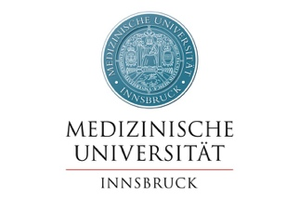
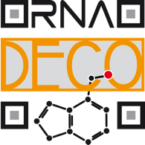
Open PhD Position at the Institute of Genomics and RNomics, Medical University of Innsbruck, Austria

RNA modifications as regulatory elements for protein synthesis

A fully funded PhD position (30 hours per week) is available in the research group of Matthias Erlacher, at the Institute of Genomics and RNomics at the Medical University of Innsbruck, Austria.
Our research group aims to better understand the process of protein synthesis in bacteria and in eukaryotes. In particular, we focus on how modifications of RNA nucleotides can shape specific steps of translation. mRNAs, rRNA and tRNAs, which are the main players in translation, are decorated by a variety of RNA modifications and have been shown to be essential for all organisms. In this project, we aim to deepen our understanding of the regulatory and functional role of certain tRNA and mRNAs modifications.

The available PhD position is embedded in the SFB RNA-deco, which is a consortium of several research teams from Vienna and Innsbruck that study different aspects of RNA modifications.

We are seeking for a highly motivated PhD student with an interest in RNA biology and protein synthesis.

Your Profile:
  - Master’s degree in biology, molecular biology, biochemistry or similar
  - Interest in basic research on bacterial an eukaryotic translation systems
  - Team player: we are a small group so we support/help each other

We offer:
- Highly motivated team and supportive environment
- Possibility to attend national and international conferences and retreats
- Fully funded position available from May 2024; salary according to FWF

The Medical University is located in Innsbruck in the heart of the alps. The city provides numerous possibilities for outdoor activities, such as skiing, hiking or biking. Innsbruck is also home of two large universities and therefore daily life is strongly shaped by students.

If you are interested, please e-mail a CV and letter of motivation to: Matthias.Erlacher@i-med.ac.at

Links:
Institute of Genomics and RNomics
RNA-deco
MCBD PhD program

